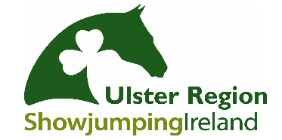
Ulster Region Awards
Booking Form

Please tick which event you wish to book:
HORSE AWARDS  20th January 2018 |  |  | PONY AWARDS  2nd February 2018

Booking Contact
Name
Contact Mobile Number
Email Address
(Booking confirmation will be emailed)

Guest List
Please complete names etc for seating arrangements
Name | Adult  £35 | Child  £20 | Dietary Requirements?
Total

Seating Preferences:
If no preferences are provided the organisers will allocate seats on your behalf

Kids Menu Choices
Half Roast Beef Dinner |  | Chicken Goujon & Chips
Children wishing to have full meal will be charged at Adult ticket price

Card Payment Authorisation Form
Name on the Card:
Type of Card: | Visa |  |  | MasterCard |  |  | Visa Debit |  | Mastercard Debit

Account Number | PLEASE SUPPLY US WITH YOUR CONTACT NUMBER TO PROCESS PAYMENT OVER THE PHONE.
Expiration Date | XXXXXX
Security Code | XXXXXXXX
Billing Address
Postcode
Phone Number

Signed: |  | Date:

For assistance in completing the form please contact:
Fiona Carson- 07711473666
Chris Bogle- 07709199474
Aldyth Roulston- 07948426262

CLOSING DATES FOR BOOKINGS

Horse Awards- Bookings close Friday 12th January 2018, with seating arrangements emailed to guests’ week commencing 15th January 2018

Pony Awards- Bookings close Friday 26th January 2018, with seating arrangements emailed to guests’ week commencing 29th January 2018

