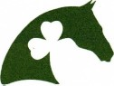
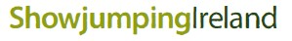

Mackey Bar Application Form

DATE

I hereby wish to apply to take part in the SJI 5 BAR Training System

Name: Membership No:

Address:
Telephone No:

Mobile:

Email Address

I am Currently Riding

Cm Pony / Horse
I am Currently Jumping

Cm M

Trainers Name

I wish to complete the SJI/Mackey BAR Level

Participant's signature (if over 18 Years )

Parent’s signature (If under 18 Years)

Please return this form to your Regional Training Rep
Chris Bogle: cbogle84@gmail.com
Cost of Assessment: £25, don’t forget to also complete ‘Ulster Region Booking form’

Showjumping Ireland (A trading name of the S.J.A.I.) Beech House, Millennium Park, Osberstown, Naas, Co. Kildare

