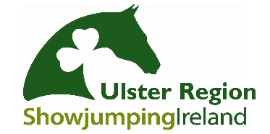
Ulster Region Awards
Booking Form
PONY AWARDS

Saturday 9th February 2019
Corick House Hotel & Spa

CLOSING DATE FOR BOOKINGS: FRIDAY 1st February 2019

Booking Contact
Name
Contact Mobile Number
Email Address
(Booking confirmation will be emailed)

Guest List (Must Be Completed)
Please complete names etc for seating arrangements
Name | Adult  £35 | Child  £20 | Dietary Requirements?
Total

Seating Preferences:

Kids Menu Choices
Half Dinner |  | Chicken Goujon & Chips |  | Sausages and Chips
Children wishing to have full meal will be charged at Adult ticket price

Card Payment Authorisation Form
Name on the Card:
Type of Card: | Visa |  |  | MasterCard |  |  | Visa Debit |  | Mastercard Debit

Account Number
Expiration Date
Security Code
Billing Address
Postcode
Phone Number

Signed: |  | Date:

Please return via email to allison@the-concept-group.com
Telephone: 07715821182 (Text- 9am- 5pm, during normal working hours)
CARD PAYMENTS ONLY WILL BE ACCEPTED

If you would prefer to pay/ book over the phone, please contact Allison Mercer
Contact number: 07715821182 (Text Only 9am- 5pm)
CLOSING DATE FOR BOOKINGS: FRIDAY 1st FEBRUARY 2019
Strictly no bookings after this date, no payments will be taken on the night. Each Booking form with completed payment will be followed up with a return confirmation email which should be presented on the night to gain entry.

Future Stars Awards
These awards are presented to Children 12 years and under who are not current SJI members. If you have a child attending who would like to receive a future star award please contact Aldyth Roulston to confirm your attendance.

Retiring Riders
An award is presented to every retiring 148 athlete. If you know of a retiring rider attending please inform Aldyth.

For Further Details regarding the awards evening please contact:
Fiona Carson- 07711473666
  - Aldyth Roulston- 07948426262

