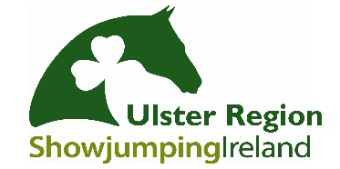
Ulster Region Ball
Booking Form
HORSE AWARDS

Saturday 26th January 2019
Corick House Hotel & Spa

CLOSING DATE FOR BOOKINGS: FRIDAY 18TH JANUARY 2019

Booking Contact
Name
Contact Mobile Number
Email Address
(Booking confirmation will be emailed)

Guest List (Must Be Completed)
Please complete names etc for seating arrangements
Name | Adult  £35 | Child  £20 | Dietary Requirements?
Total

Seating Preferences:

Kids Menu Choices
Half Dinner |  | Chicken Goujon & Chips |  | Sausages and Chips
Children wishing to have full meal will be charged at Adult ticket price

Card Payment Authorisation Form
Name on the Card:
Type of Card: | Visa |  |  | MasterCard |  |  | Visa Debit |  | Mastercard Debit

Account Number
Expiration Date
Security Code
Billing Address
Postcode
Phone Number

Signed: |  | Date:

Please return via email to allison@the-concept-group.com
Telephone: 07715821182 (Text- 9am- 5pm during Normal working hours)
CARD PAYMENTS ONLY WILL BE ACCEPTED

If you would prefer to pay/ book over the phone, please contact Allison Mercer
Contact number: 07715821182 (Text Only 9am- 5pm)
CLOSING DATE FOR BOOKINGS: FRIDAY 18TH JANUARY 2019

Strictly no bookings after this date, no payments will be taken on the night. Each Booking form with completed payment will be followed up with a return confirmation email which should be presented on the night to gain entry.
For Further Details regarding the awards evening please contact:
Fiona Carson- 07711473666
Aldyth Roulston- 07948426262

